**EXPERIMENT NO 4**

**SCREENSHOTS:**

1. HOME(PART 1):



1. HOME(PART 2):



3. ABOUT US



4. CONTACT US

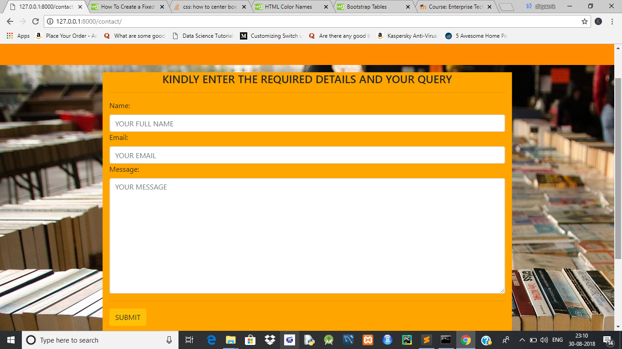

5. LOGIN

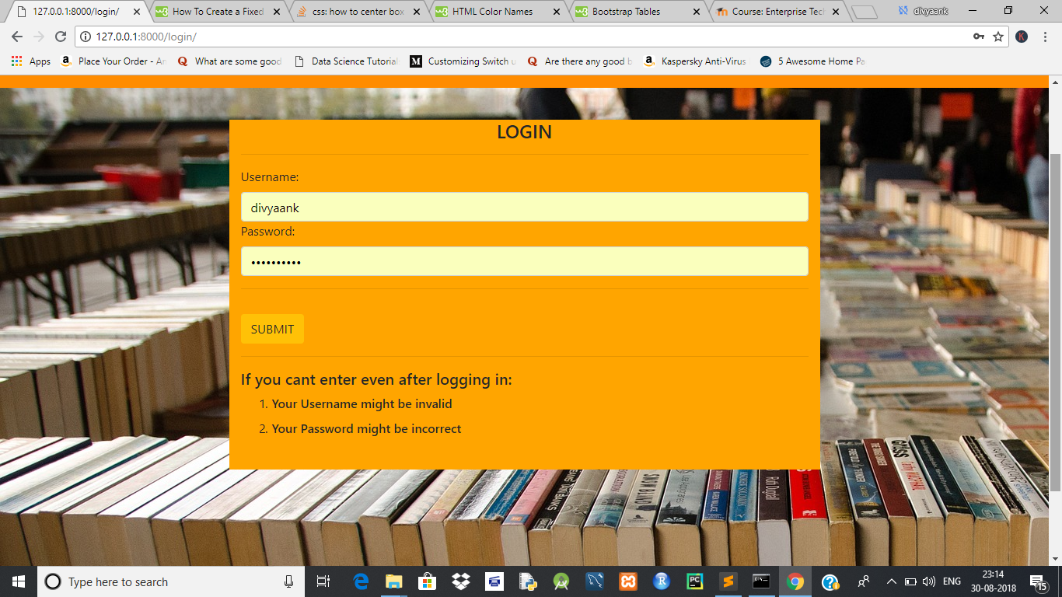

6. REGISTER



7. PRODUCT CARD VIEW

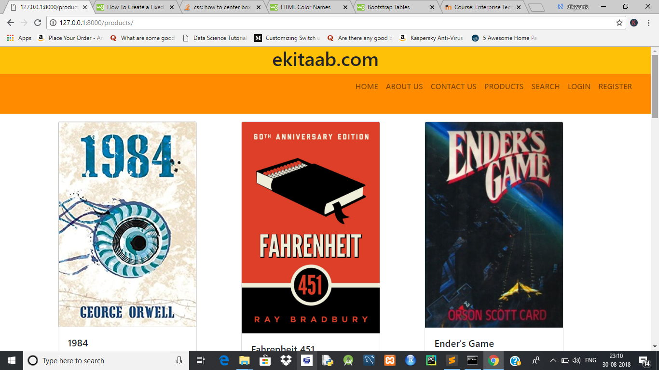

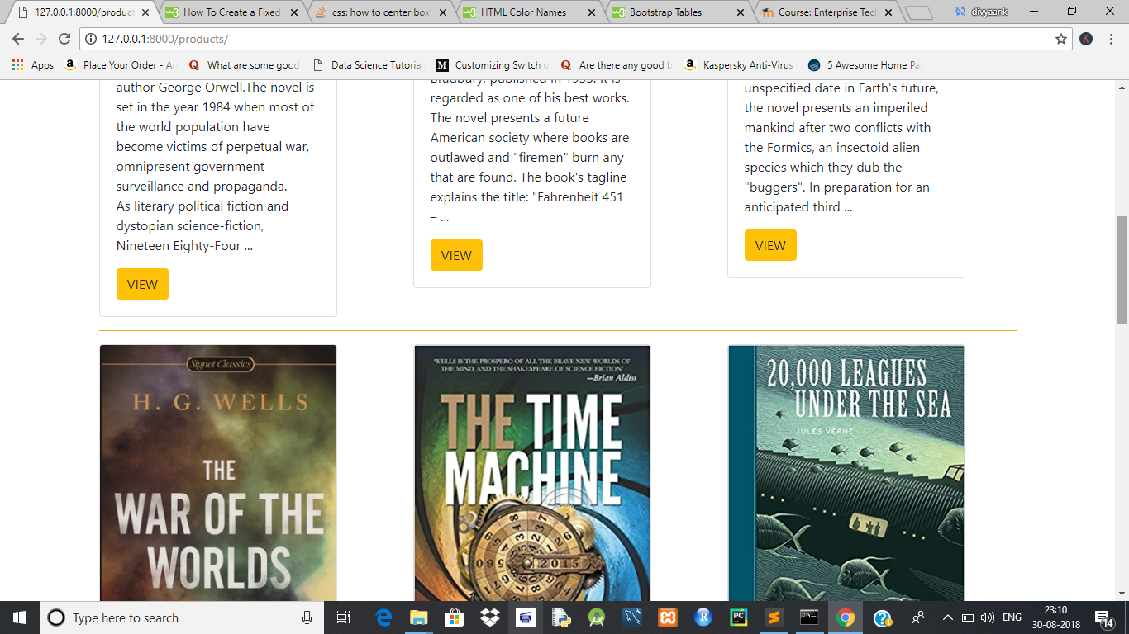

8. PRODUCT DETAIL VIEW

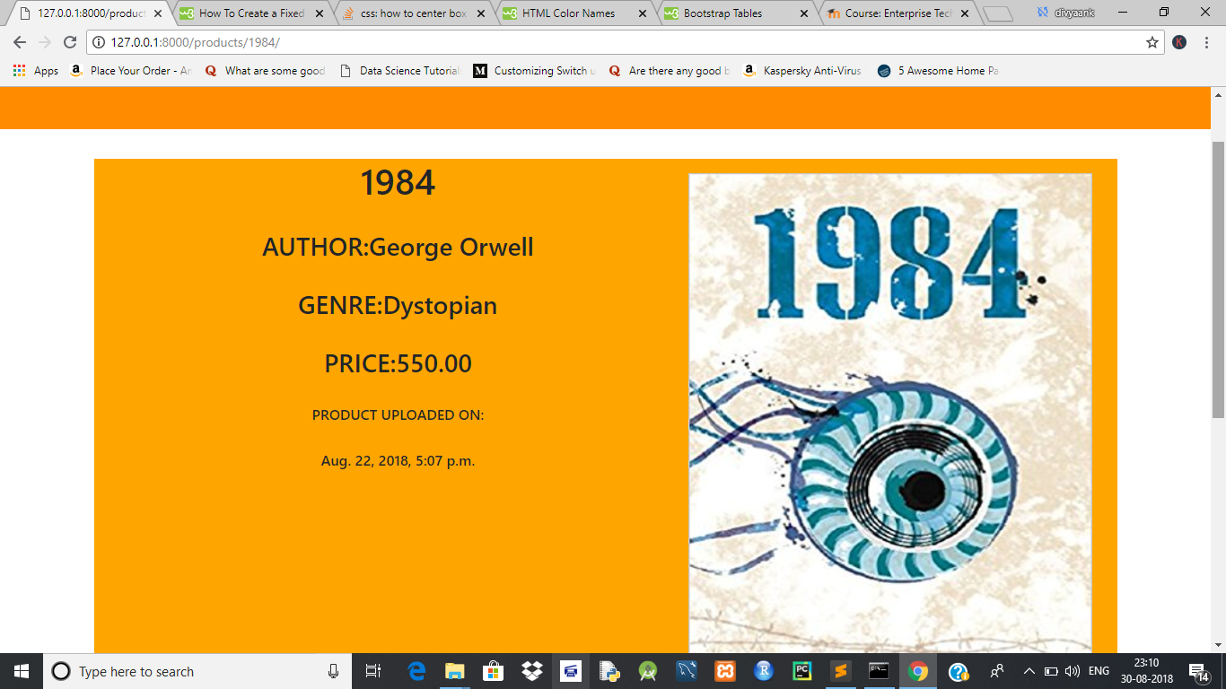

9. PRODUCT SEARCH VIEW

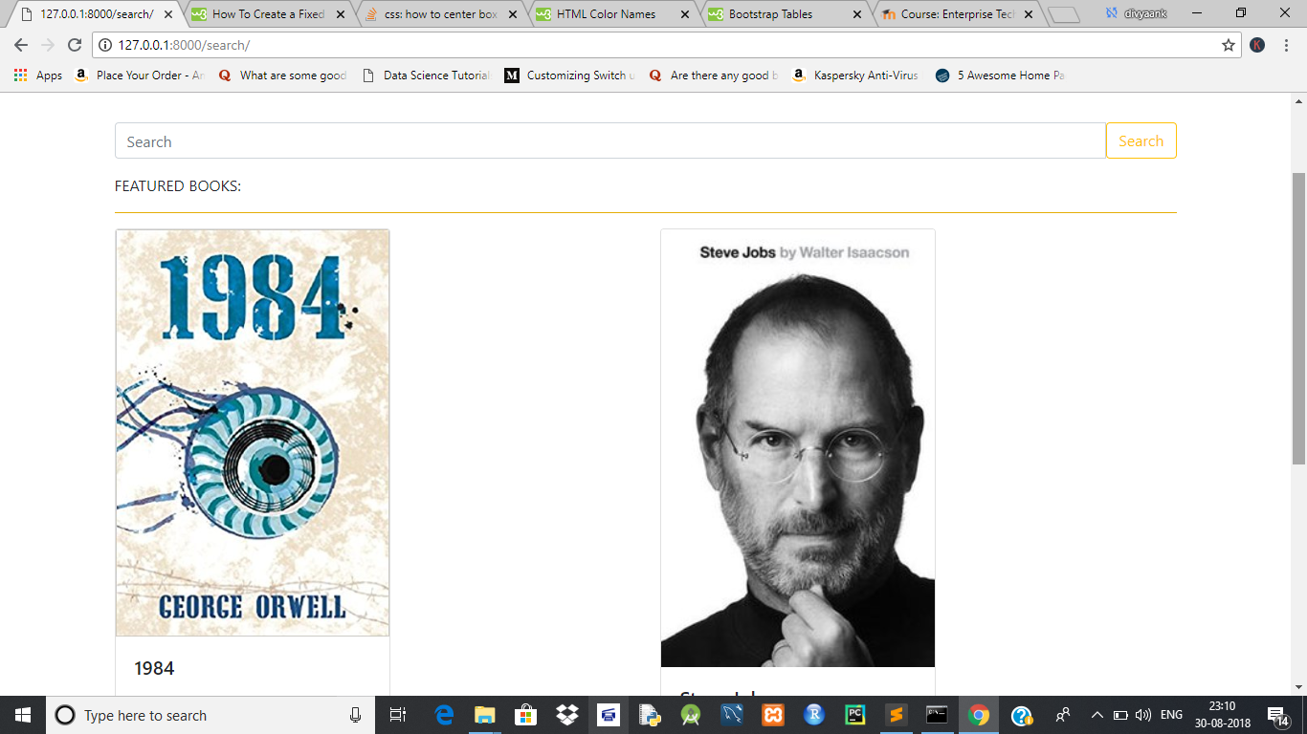

10. CART VIEW

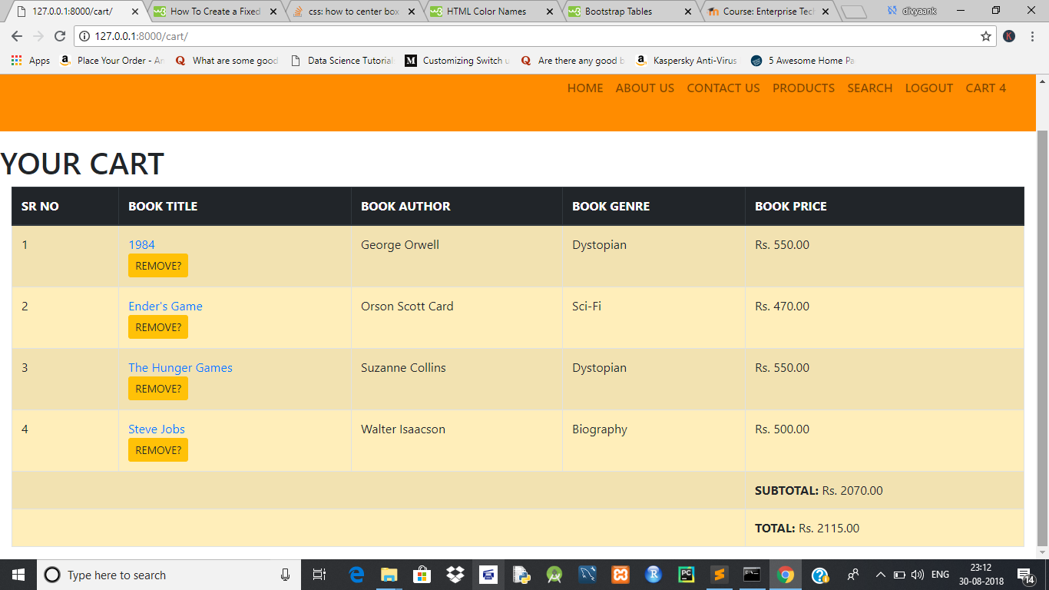

**CODE OF CART VIEW:**

**urls.py**

from django.urls import path,re_path

from .views import (

cart_home,

cart_update,

)

app_name = 'carts'

urlpatterns = [

path('', cart_home, name='home'),

re_path(r'^update/$', cart_update, name='update'),

]

**models.py**

from django.db import models

from django.conf import settings

from products.models import Product

from django.db.models.signals import pre_save, post_save, m2m_changed

User = settings.AUTH_USER_MODEL

class CartManager(models.Manager):

def new_or_get(self, request):

cart_id = request.session.get("cart_id", None)

qs=self.get_queryset().filter(id=cart_id)

if qs.count() == 1:

new_obj=False

cart_obj = qs.first()

if request.user.is_authenticated and cart_obj.user is None:

cart_obj.user = request.user

cart_obj.save()

else:

cart_obj = Cart.objects.new(user=request.user)

new_obj=True

request.session["cart_id"] = cart_obj.id

return cart_obj,new_obj

def new(self, user=None):

user_obj=None

if user is not None:

if user.is_authenticated:

user_obj = user

return self.model.objects.create(user=user_obj)

class Cart(models.Model):

user = models.ForeignKey(User, null=True, blank=True, on_delete=models.CASCADE)

products = models.ManyToManyField(Product, blank=True)

total = models.DecimalField(default=0.00, max_digits=8, decimal_places=2)

subtotal = models.DecimalField(default=0.00, max_digits=8, decimal_places=2)

updated = models.DateTimeField(auto_now=True)

timestamp = models.DateTimeField(auto_now_add=True)

objects = CartManager()

def __str__(self):

return str(self.id)

def m2m_changed_cart_receiver(sender, instance, action, *args, **kwargs):

if action=='post_add' or action=='post_remove' or action=='post_clear':

products = instance.products.all()

total = 0

for x in products:

total += x.price

if instance.subtotal != total:

instance.subtotal = total

instance.save()

m2m_changed.connect(m2m_changed_cart_receiver,sender=Cart.products.through)

def pre_save_cart_receiver(sender, instance,*args,**kwargs):

if instance.subtotal > 0:

instance.total = instance.subtotal + 45

else:

instance.total = 0.00

pre_save.connect(pre_save_cart_receiver,sender=Cart)

**views.py**

from django.shortcuts import render, redirect

from .models import Cart

from products.models import Product

def cart_home(request):

cart_obj,new_obj = Cart.objects.new_or_get(request)

return render(request,"carts/home.html",{"cart":cart_obj})

def cart_update(request):

product_id = request.POST.get("product_id")

if product_id is not None:

try:

product_obj = Product.objects.get(id=product_id)

except Product.DoesNotExist:

print("PRODUCT IS GONE!!")

return redirect("cart:home")

cart_obj, new_obj = Cart.objects.new_or_get(request)

if product_obj in cart_obj.products.all():

cart_obj.products.remove(product_obj)

else:

cart_obj.products.add(product_obj)

request.session['cart_items'] = cart_obj.products.count()

return redirect("cart:home")

**cart-base.html**

{% load static %}

<!DOCTYPE html>

<html lang="en">

<head>

<meta charset="utf-8">

<meta name="viewport" content="width=device-width, initial-scale=1, shrink-to-fit=no">

{% include "base/css.html" %}

{% block main_css %}{% endblock %}

</head>

<body>

{% include 'base/header.html' %}

{% include 'base/navbar.html' with brand_name="ekitaab.com"%}

{% block content %}{% endblock %}

{% include "base/js.html" %}

</body>

</html>

**home.html**

{% extends "cart-base.html" %}

{% block content %}

<h1>YOUR CART</h1>

{% if cart.products.exists %}

<div class="container-fluid">

<div class="row">

<div class="col-lg-12">

<table class="table table-striped table-bordered table-warning">

<thead class="thead-dark">

<tr>

<th scope="col">SR NO</th>

<th scope="col">BOOK TITLE</th>

<th scope="col">BOOK AUTHOR</th>

<th scope="col">BOOK GENRE</th>

<th scope="col">BOOK PRICE</th>

</tr>

</thead>

<tbody>

{% for product in cart.products.all %}

<tr>

<td scope="row">{{ forloop.counter }}</td>

<td><a href="{{ product.get_absolute_url }}">{{ product.title }}</a>

{% include 'products/snippets/update-cart.html' with product=product cart=cart in_cart=True %}

</td>

<td>{{ product.author }}</td>

<td>{{ product.genre }}</td>

<td>Rs. {{ product.price }}</td>

</tr>

{% endfor %}

<tr>

<td colspan="4"></td>

<td><b>SUBTOTAL: </b>Rs. {{ cart.subtotal }}</td>

</tr>

<tr>

<td colspan="4"></td>

<td><b>TOTAL: </b>Rs. {{ cart.total }}</td>

</tr>

</tbody>

</table>

</div>

</div>

</div>

{% else %}

<p class="lead">CART IS CURRENTLY EMPTY</p>

{% endif %}

{% endblock %}

**apps.py**

from django.apps import AppConfig

class CartsConfig(AppConfig):

name = 'carts'

**admin.py**

from django.contrib import admin

from .models import Cart

admin.site.register(Cart)

**update-cart.html**

<form method="POST" action='{% url "cart:update" %}' class="form">{% csrf_token %}

<input type="hidden" name="product_id" value="{{ product.id }}"/>

{% if request.user.is_authenticated %}<!-- FOR ACTUAL UDEMY CODE REMOVE THIS -->

{% if in_cart %}

<button type="submit" class="btn btn-warning btn-sm">REMOVE?</button>

{% else %}

{% if product in cart.products.all %}

<button type="submit" class="btn btn-warning">REMOVE?</button>

{% else %}

<button type="submit" class="btn btn-warning">ADD TO CART?</button>

{% endif %}

{% endif %}

{% endif %}

</form>

**settings.py**

"""

Django settings for ecommerce project.

Generated by 'django-admin startproject' using Django 2.1.

For more information on this file, see

https://docs.djangoproject.com/en/2.1/topics/settings/

For the full list of settings and their values, see

https://docs.djangoproject.com/en/2.1/ref/settings/

"""

import os

# Build paths inside the project like this: os.path.join(BASE_DIR, ...)

BASE_DIR = os.path.dirname(os.path.dirname(os.path.abspath(__file__)))

# Quick-start development settings - unsuitable for production

# See https://docs.djangoproject.com/en/2.1/howto/deployment/checklist/

# SECURITY WARNING: keep the secret key used in production secret!

SECRET_KEY = 'xsz)#i-v^jv)-9od3pf#+i%8uprkeni*uzvc)27!=9csj_l0z4'

# SECURITY WARNING: don't run with debug turned on in production!

DEBUG = True

ALLOWED_HOSTS = []

# Application definition

INSTALLED_APPS = [

'django.contrib.admin',

'django.contrib.auth',

'django.contrib.contenttypes',

'django.contrib.sessions',

'django.contrib.messages',

'django.contrib.staticfiles',

#apps made

'products',

'search',

'tags',

'carts',

]

MIDDLEWARE = [

'django.middleware.security.SecurityMiddleware',

'django.contrib.sessions.middleware.SessionMiddleware',

'django.middleware.common.CommonMiddleware',

'django.middleware.csrf.CsrfViewMiddleware',

'django.contrib.auth.middleware.AuthenticationMiddleware',

'django.contrib.messages.middleware.MessageMiddleware',

'django.middleware.clickjacking.XFrameOptionsMiddleware',

]

ROOT_URLCONF = 'ecommerce.urls'

TEMPLATES = [

{

'BACKEND': 'django.template.backends.django.DjangoTemplates',

'DIRS': [os.path.join(BASE_DIR, 'templates')],

'APP_DIRS': True,

'OPTIONS': {

'context_processors': [

'django.template.context_processors.debug',

'django.template.context_processors.request',

'django.contrib.auth.context_processors.auth',

'django.contrib.messages.context_processors.messages',

],

},

},

]

WSGI_APPLICATION = 'ecommerce.wsgi.application'

# Database

# https://docs.djangoproject.com/en/2.1/ref/settings/#databases

DATABASES = {

'default': {

'ENGINE': 'django.db.backends.sqlite3',

'NAME': os.path.join(BASE_DIR, 'db.sqlite3'),

}

}

# Password validation

# https://docs.djangoproject.com/en/2.1/ref/settings/#auth-password-validators

AUTH_PASSWORD_VALIDATORS = [

{

'NAME': 'django.contrib.auth.password_validation.UserAttributeSimilarityValidator',

},

{

'NAME': 'django.contrib.auth.password_validation.MinimumLengthValidator',

},

{

'NAME': 'django.contrib.auth.password_validation.CommonPasswordValidator',

},

{

'NAME': 'django.contrib.auth.password_validation.NumericPasswordValidator',

},

]

# Internationalization

# https://docs.djangoproject.com/en/2.1/topics/i18n/

LANGUAGE_CODE = 'en-us'

TIME_ZONE = 'UTC'

USE_I18N = True

USE_L10N = True

USE_TZ = True

# Static files (CSS, JavaScript, Images)

# https://docs.djangoproject.com/en/2.1/howto/static-files/

STATIC_URL = '/static/'

STATICFILES_DIRS = [

os.path.join(BASE_DIR, "static_my_proj")

]

STATIC_ROOT = os.path.join(os.path.dirname(BASE_DIR), "static_cdn", "static_root")

MEDIA_URL = '/media/'

MEDIA_ROOT = os.path.join(os.path.dirname(BASE_DIR), "static_cdn", "media_root")